**Kocaeli University, Electronics and Telecommunications Engineering**

**Digital Communications Laboratory**

**Experiment 1: Sampling and Reconstruction–Simulink Lab Report (26.02.2024)**

|  |
| --- |
| Name-Surname-Number: |
| Name-Surname-Number: |
| Name-Surname-Number: |

**Case1: Signal with single frequency**

Construct the below block diagram in Simulink. Set signal parameter according to Table 1.

In this step, you generate a cosine signal and sampled it every $T_{s}$ = 0.1sec. It means that its sampling frequency equals to $f_{s} =\frac{1}{T_{s}}=10 Hz$. Table 2 includes sampling signal’s values. Run the code for 1 sec.

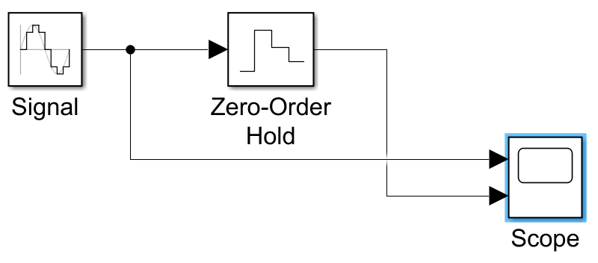

Figure 1: Block diagram used to create and display x(t) and x[n]

|  |  |
| --- | --- |
| Amplitude | 1 |
| Frequency | 1 |
| Phase | $π/2$*(It is necessary to generate cosine signal)* |
| Zero-order hold sample time | 0.1 |

Table 1: Signal parameters for Figure 1

**Q1)** Fill Table 2 for only one period of the signal.The Zero-Order Hold block performs sampling of the continuous time sinusoid with a specified sampling period.

|  |  |  |  |  |  |  |  |  |  |  |
| --- | --- | --- | --- | --- | --- | --- | --- | --- | --- | --- |
| **n** | **0** | **1** | **2** | **3** | **4** | **5** | **6** | **7** | **8** | **9** |
| **x[n] with $θ=\frac{π}{2}$** | **0** | **1/10** | **1/20** | **1/30** | **1/40** | **1/50** | **1/60** | **1/70** | **1/80** | **1/90** |

Table 2: Discrete signal value for Figure 1

**Q2)** Set the sampling value of zero-order hold as 0.5. Use the same signal with phases $θ=\frac{π}{2}$ and 0. Run the code for 5 second. Fill the Table 3. If there is any difference between line 2 and line 3 of the table, explain why.

|  |  |  |  |  |  |  |  |  |  |  |
| --- | --- | --- | --- | --- | --- | --- | --- | --- | --- | --- |
| **n** | **0** | **1** | **2** | **3** | **4** | **5** | **6** | **7** | **8** | **9** |
| **x[n] with $θ=\frac{π}{2}$** | **0** | **1/10** | **1/20** | **1/30** | **1/40** | **1/50** | **1/60** | **1/70** | **1/80** | **1/90** |
| **x[n] with $θ=0$** | **0** | **0** | **0** | **0** | **0** | **0** | **0** | **0** | **0** | **0** |

Table 3: Discrete signal value for Q2

**Case 2: Signal with two frequency components**

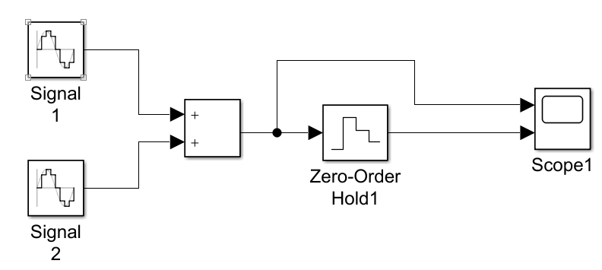

Figure 2: Form of the block diagram for Case-2

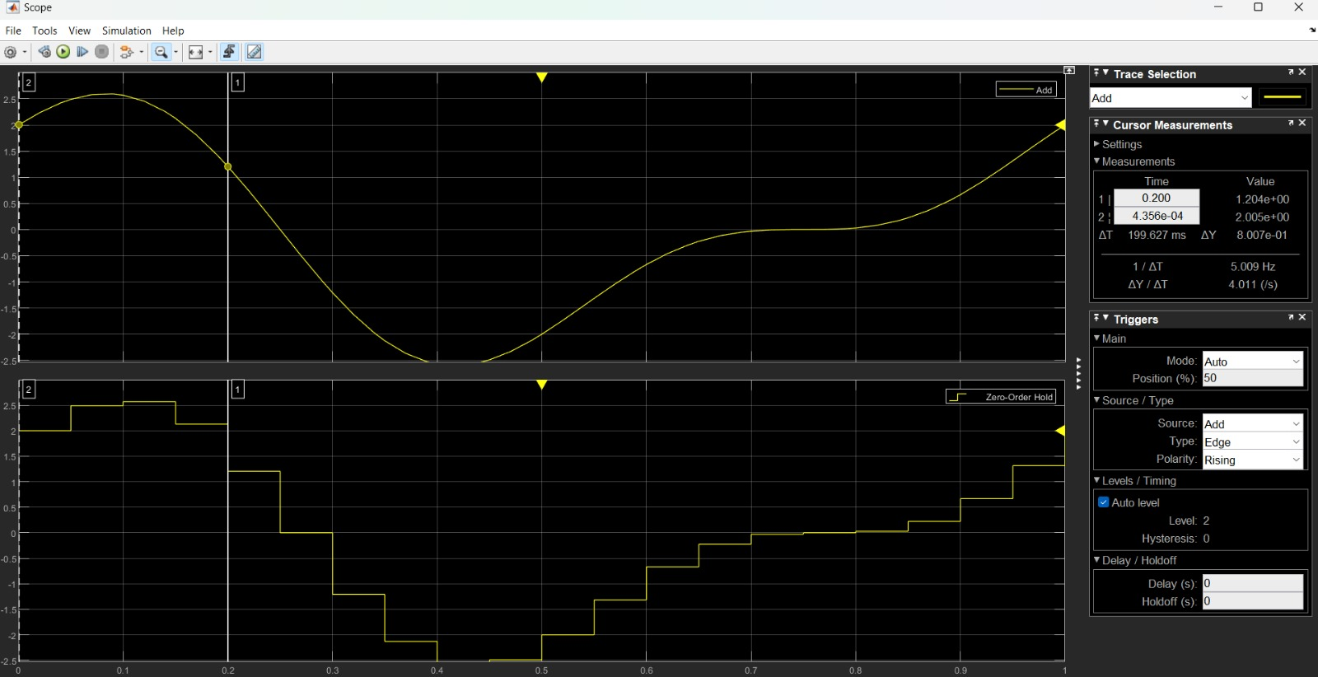**Q3)**Generate $x\left(t\right)=2\cos\left(2πt\right)+sin⁡(4πt)$ in Simulink. Sample the signal at a sampling rate $f_{s}$ = 20 samples/sec (sampling period $T_{s} = 1/f_{s}$) to produce the discrete-time signal x[n]. Run the simulation for duration of 1 sec and display both these waveforms on an oscilloscope. Add the screen-shots to your report. Explain what you see. How many samples did you take? Which component is important for sampling frequency selection?

Generate $x\left(t\right)=2\cos\left(2πt\right)+sin⁡(4πt)$ in Simulink.

**Case 3: Exploration of Aliasing**

**Q4)a)** Generate $x_{1}\left(t\right)=sin⁡(2πt)$*(in the block diagram it is written as Signal3)* and $x_{2}\left(t\right)=sin⁡(22πt)$*(in the block diagram it is written as Signal 4)*in Simulink. Sample these signals at a sampling rate $f_{s}$ = 10 samples/sec (10 Hz). Set stop time as 1 sec. Observe outputs of Scope 3 in the time domain and their sampled versions in Scope 2. Add your scope screen-shots to your reports and explain why do their sampled spectrum is identical while these signals are different.

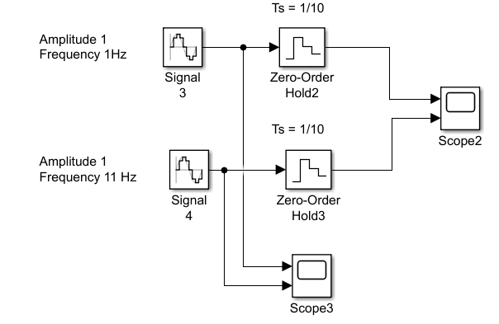

Figure 3: Form of the block diagram for Case-3

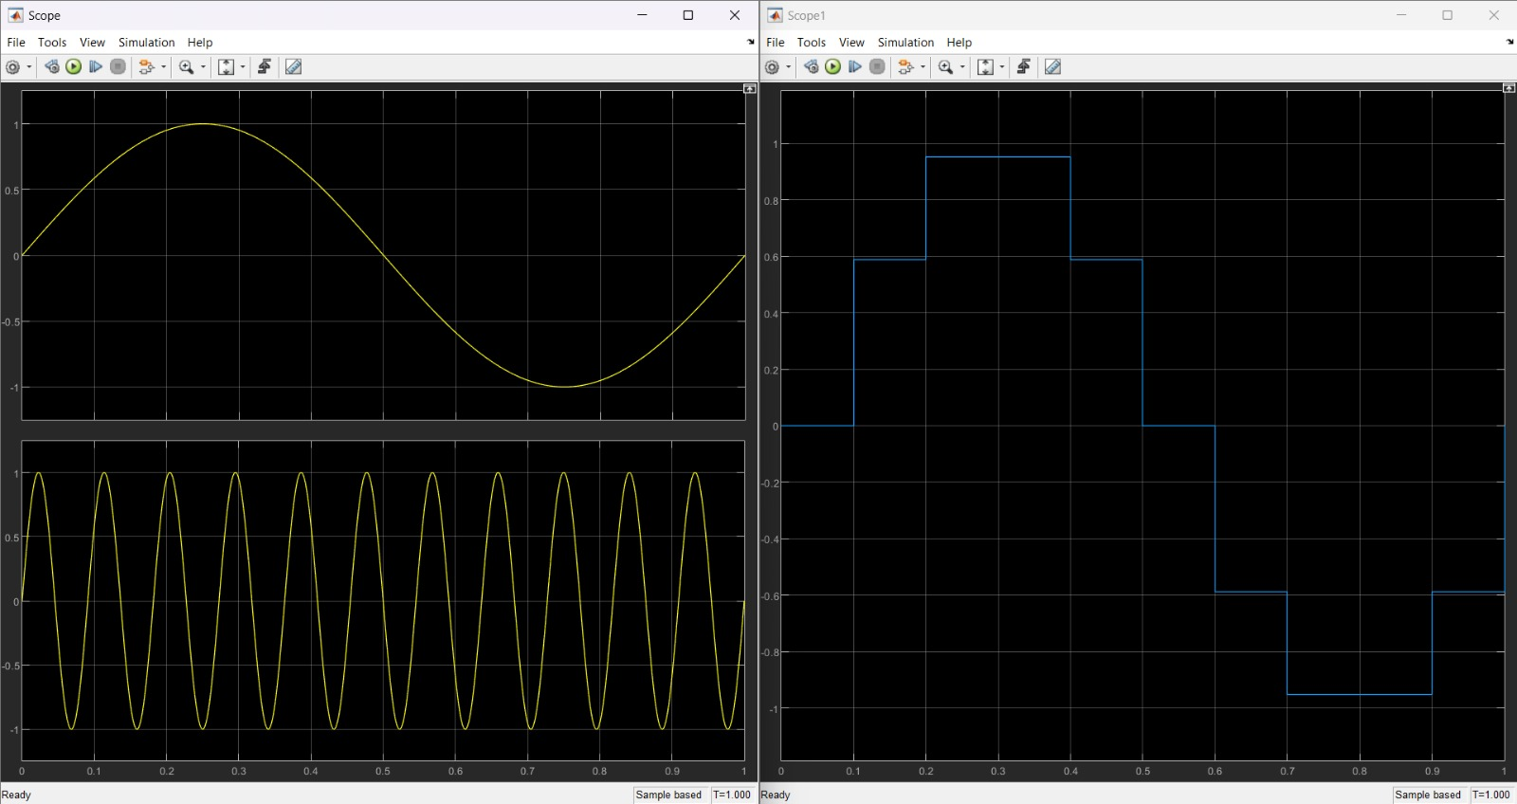

**b)** Change $x_{2}\left(t\right)=sin⁡(30πt)$. Observe outputs of Scope 3 in the time domain and their sampled versions in Scope 2. Add your scope screen-shots to your reports do their ( $x_{1}\left(t\right) and x_{2}\left(t\right))$ sampled spectrum is identical now?

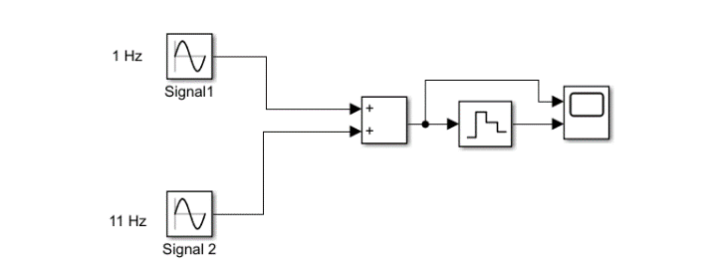

Figure 3: Form of the block diagram for Case-3-c

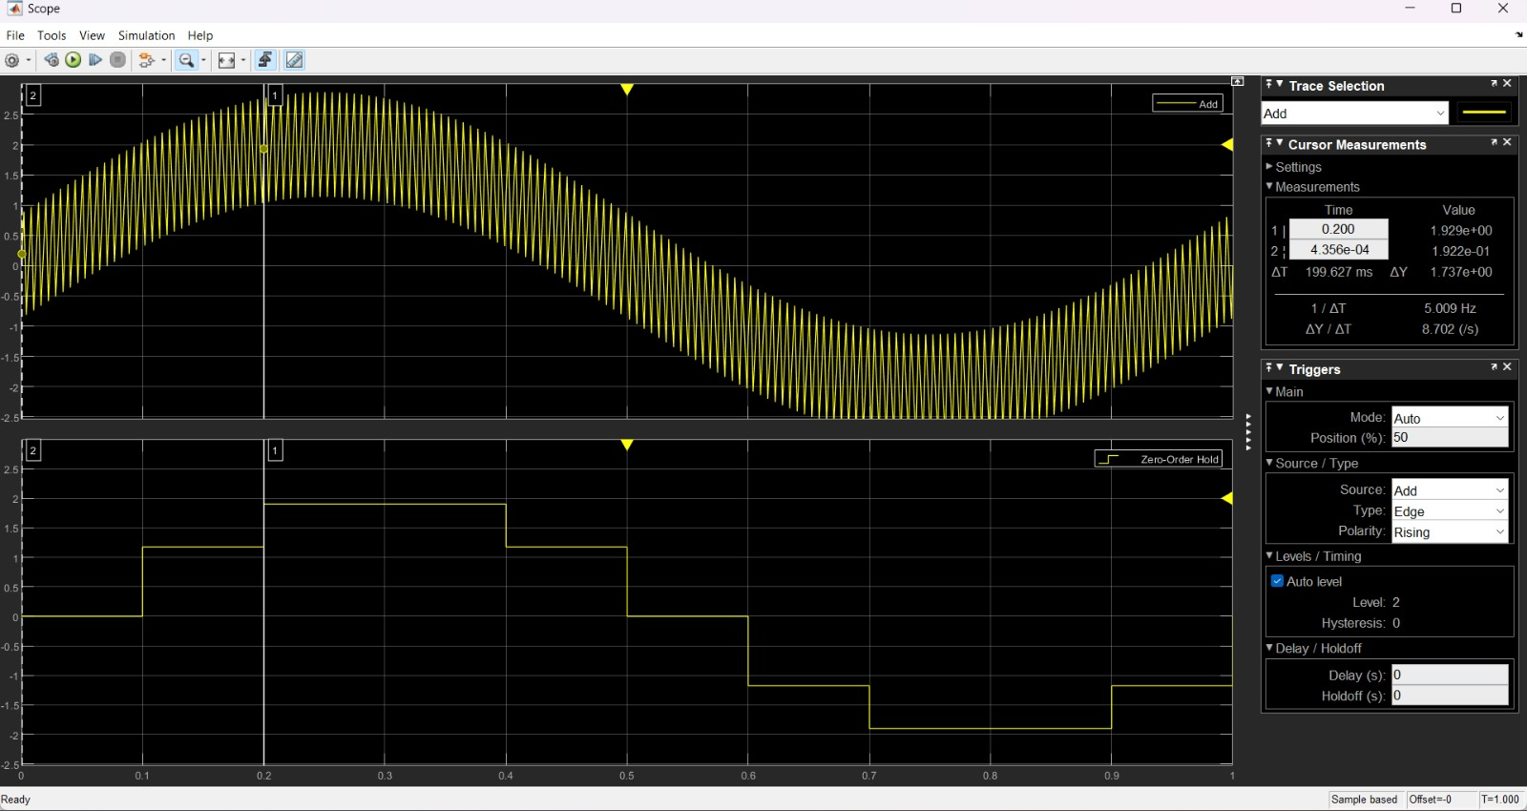

**c)**Sum $x_{1}\left(t\right)=sin⁡(2πt)$ and $x_{2}\left(t\right)=sin⁡(22πt)$ in Simulink. Sample these signals at a sampling rate $f_{s}$ = 10 samples/sec (10 Hz). Set stop time as 1 sec. Add your scope screenshots to your reports and compare with Case 3-a.

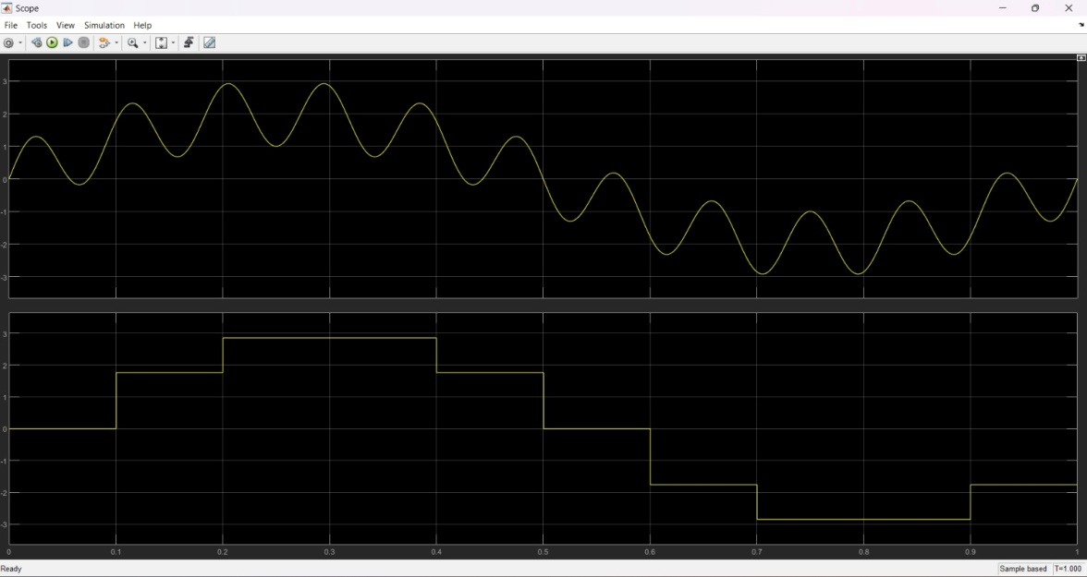

**Case 4: Duty Cycle of Rectangular Pulse Effect on Sampling Signal**

Construct the below block diagram in Simulink.

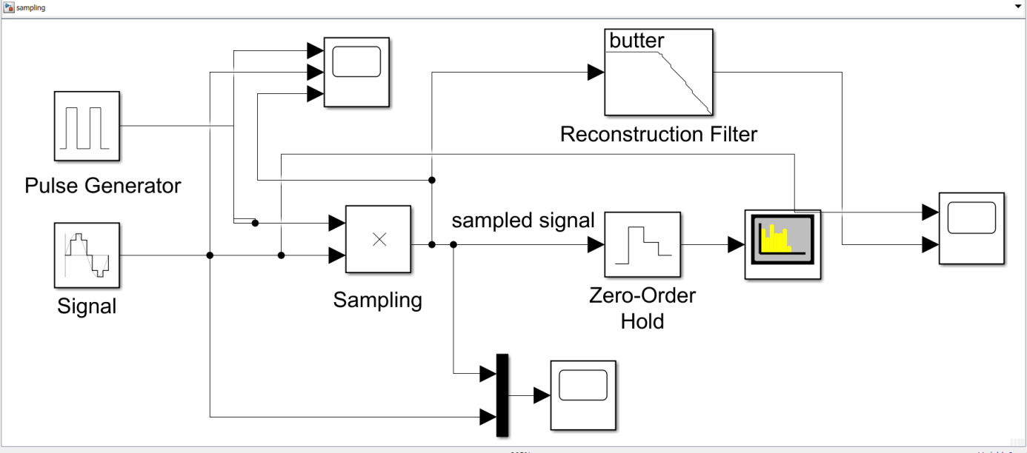

Figure 4: A general sampling scenario

Signal is generated and is multiplied with pulse generator’s output.

The signal frequency is set to 5 Hz. Sampled it every $T_{s}$ = 0.1 sec. Thus, $f_{s}=2f_{m}$.

1. Set the signal phases is 0 and observe the sampled signal and reconstructed signal. Take a screen-shot of time domain signals and add your report.
2. Set the signal phase is and observe the sampled signal and reconstructed signal. Take a screen-shot of time domain signals and add your report.
3. Set the signal phase is and observe the sampled signal and reconstructed signal. Take a screen-shot of time domain signals and add your report.

Do the reconstructed signal of A and B same? Explain both cases.

1. Set different period value for pulse generator and observe its effect on sampled and reconstructed signals.
2. Changes cut off frequency of reconstructed filter and observe its effect on sampled and reconstructed signals.
3. Change duty cycle of the pulse generator given in Table 4 and observe its effect on

* sampled signal in time domain and
* sampled signal in frequency domain (vertical axis unit must be POWER: dBm)
* required cut-off frequency of the LPF.

Add screen-shots of them and explain its effect.

1. Fill the below table.

|  |  |  |
| --- | --- | --- |
| Duty Cycle | -3dB BW of the sampled signal | Cut-off frequency of the LPF |
| 5% |  |  |
| 20% |  |  |
| 50% |  |  |

Table 4: BW ofQ3 and Q4